

ADEENA YASIN
REG# 8-FMS/BSBIN/F21

DATA SET (Student performance in exam)
https://datawrapper.dwcdn.net/GjKT1/2/

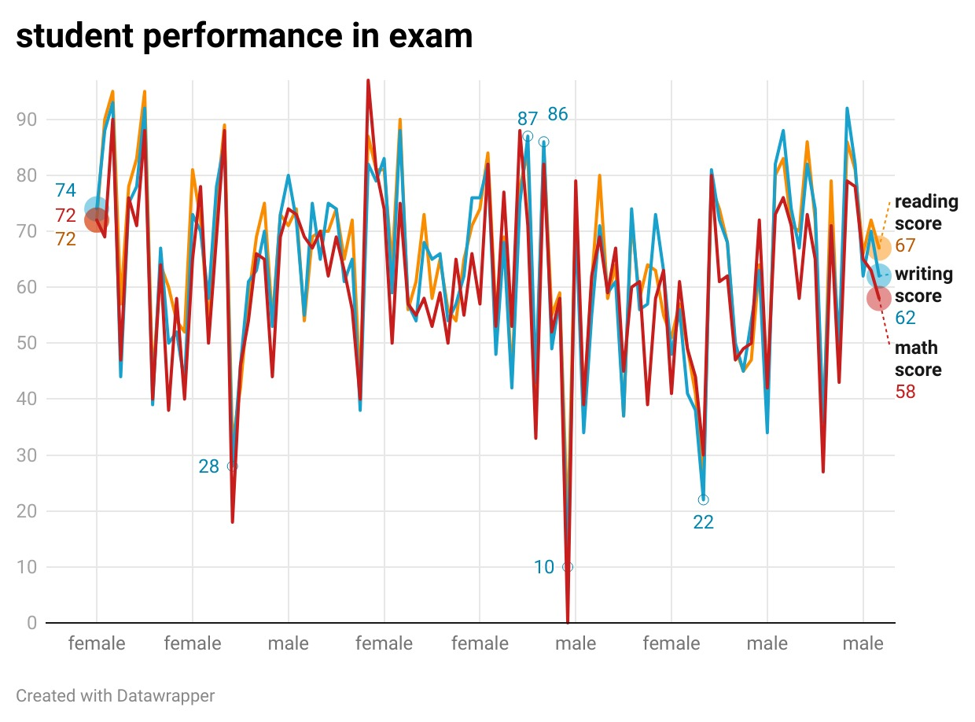
FLOURISH LINK:
https://public.flourish.studio/visualisation/23043118/
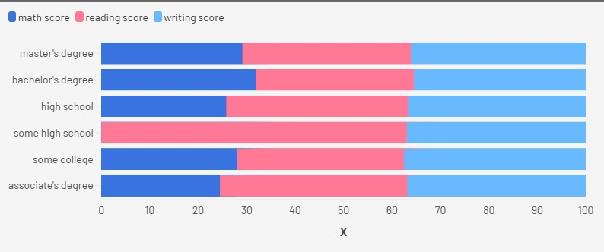
Data Visualization Report
1. Data Summary
We used a student performance dataset sourced from Kaggle. The dataset includes variables such as gender, race/ethnicity, parental level of education, lunch type, test preparation course, and scores in math, reading, and writing. We selected this dataset because it offers diverse demographic and academic data, making it ideal for visual analysis of student achievement patterns.
2. Visualization Choice
- In Datawrapper, we created a line chart (https://datawrapper.dwcdn.net/GjKT1/2/)
to show the average scores (math, reading, writing) for students grouped by test preparation status. This helped us observe performance trends across different subjects.
- In Flourish, we built a bar-scatter chart(https://public.flourish.studio/visualisation/23043118/) to compare performance based on gender and parental education level. The interactive format allows users to explore relationships more dynamically.
3. Tool Comparison
- Datawrapper is user-friendly and efficient for creating quick, clean, and professional static charts.
- Flourish provides more customization and interactivity (tooltips, animations), ideal for storytelling and presentations, although it requires a bit more learning.
4. Insights
- Students who completed the test preparation course showed consistently higher scores in all subjects.
- Students whose parents have higher education levels tend to perform better, especially in math and reading.These insights help highlight areas for focused educational support.

